**I. AWS Screenshots**

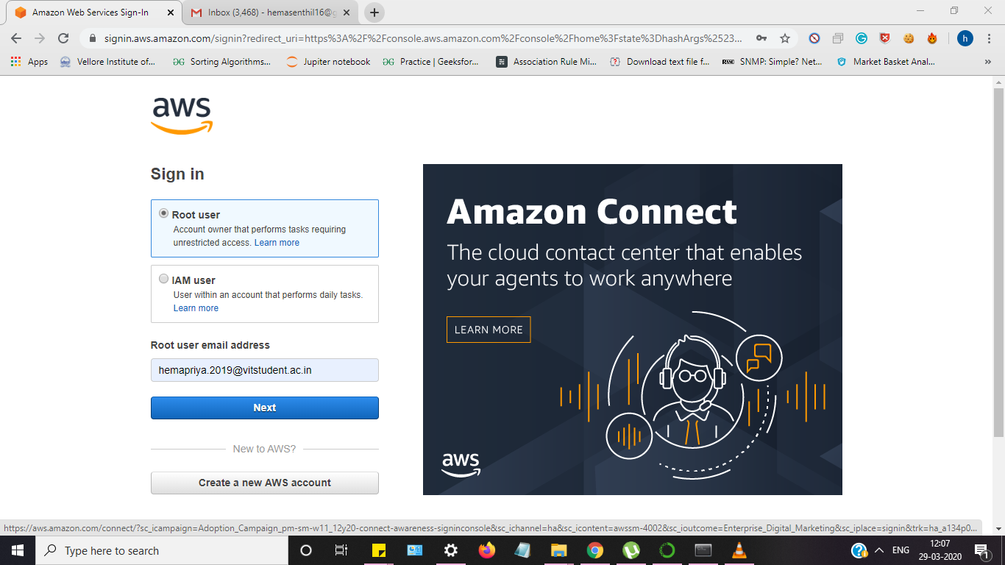**a. AWS login screen with username**

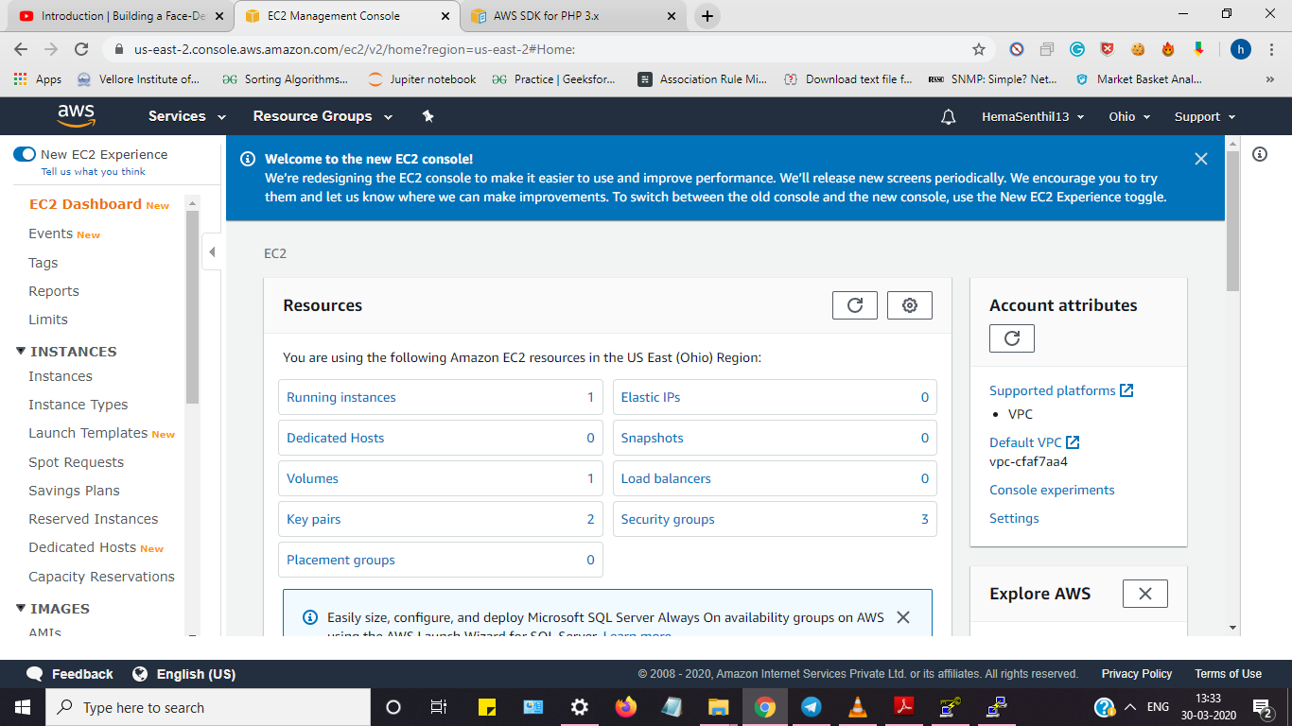**b. EC2 Dashboard**

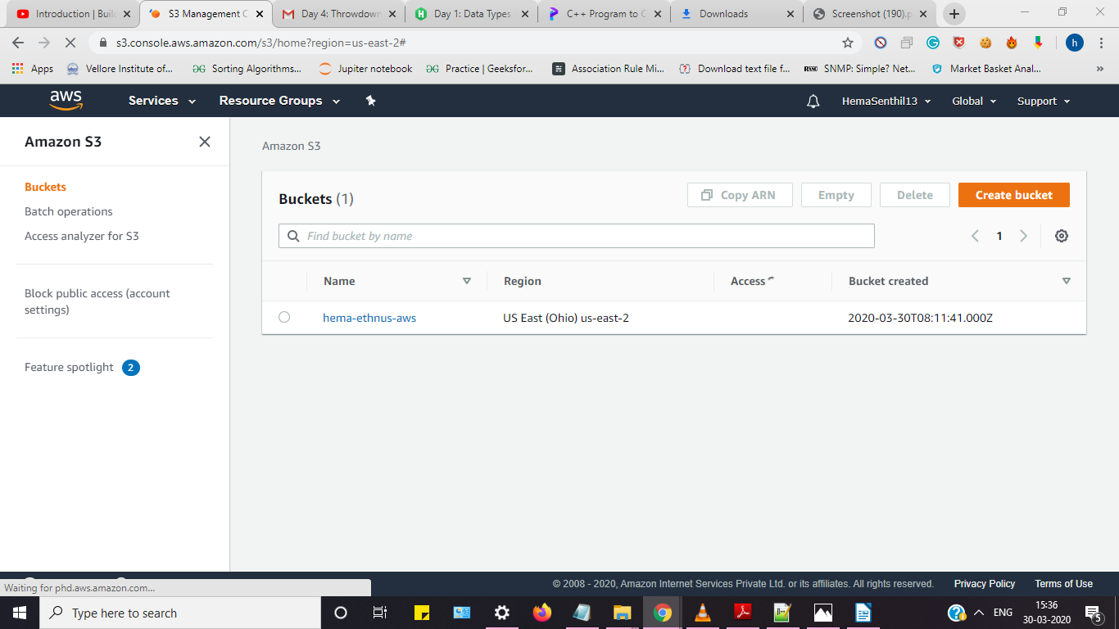**c. S3 Dashboard**

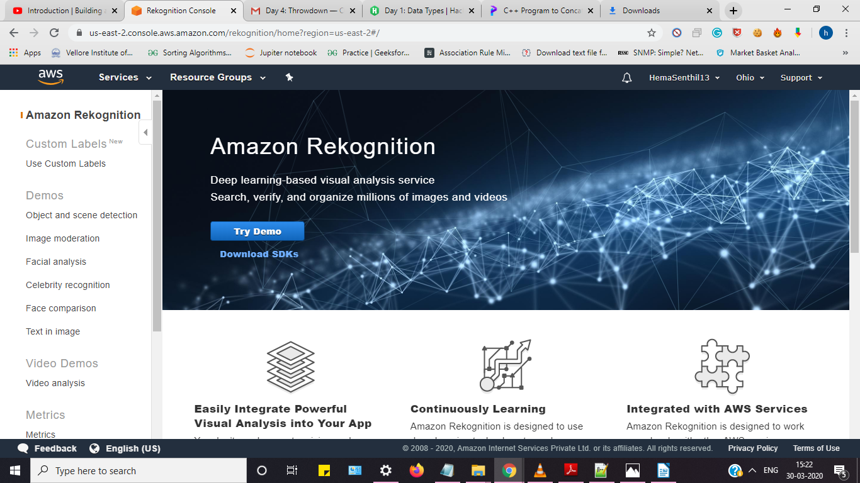**d. Rekognition Dashboard**

**II. EC2 Screenshots**

**Launching an instance**

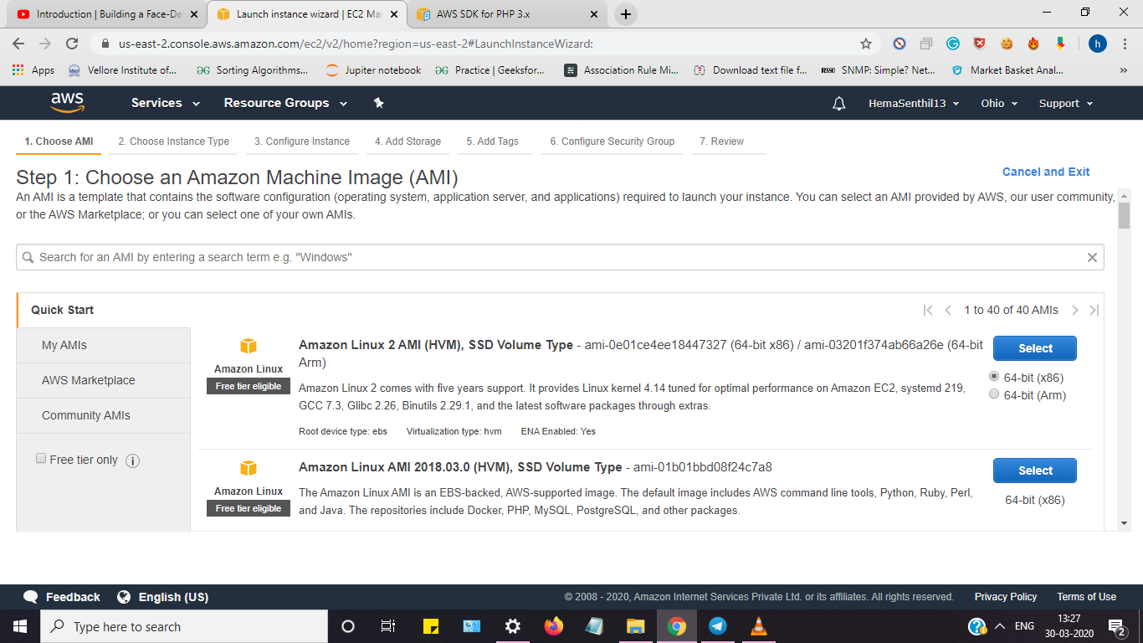**a. Choosing an AMI Type**

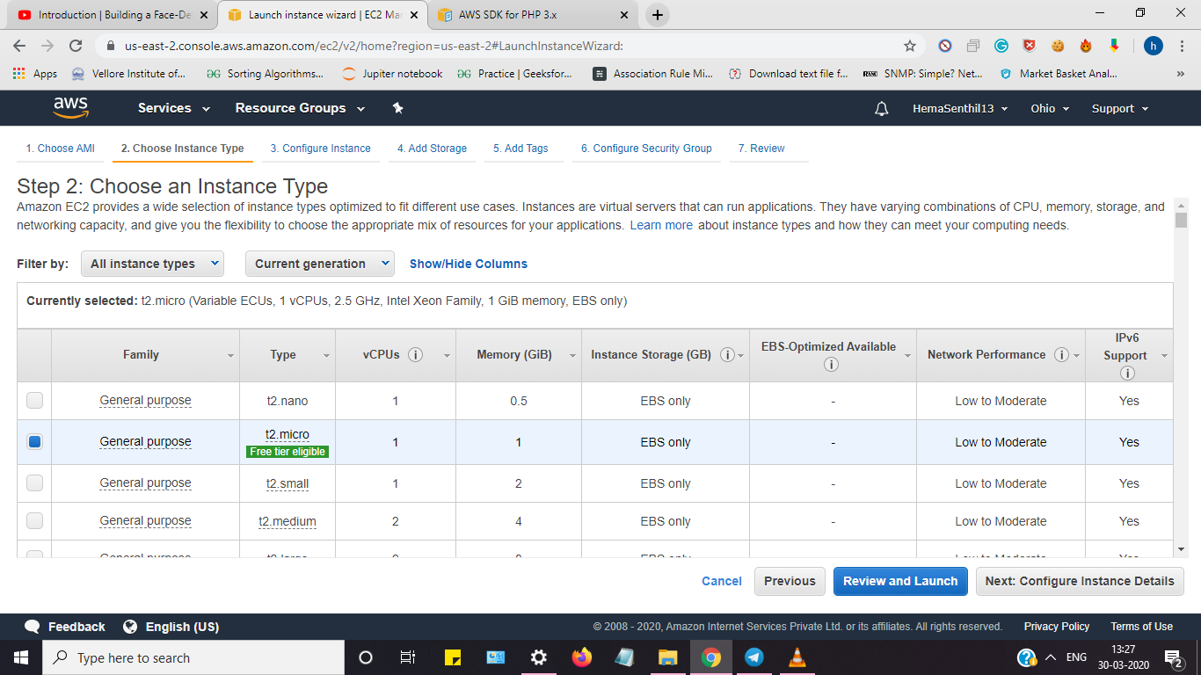**b. Choosing instance**

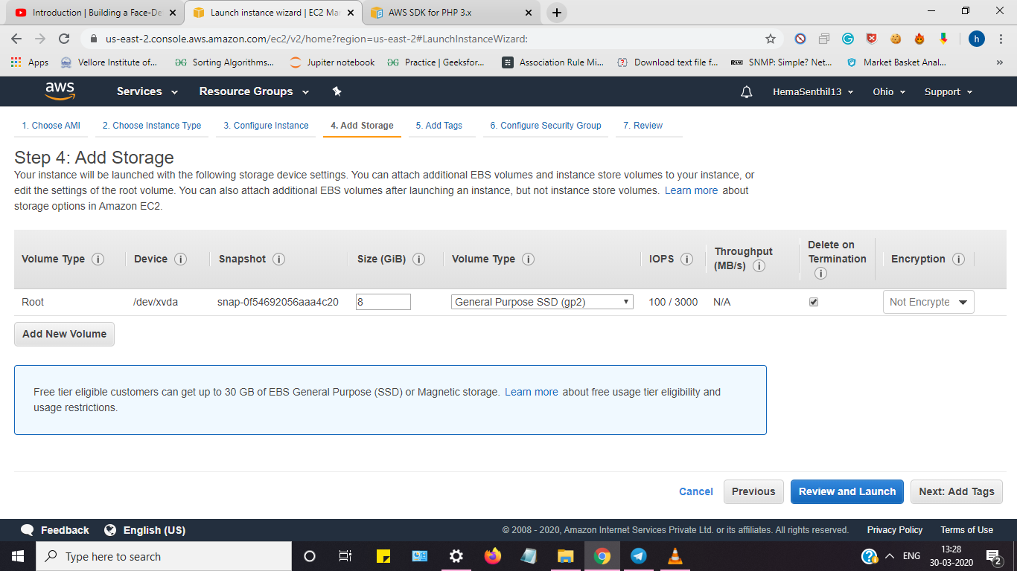**c. Adding Storage**

**d. Configuring Security Group**

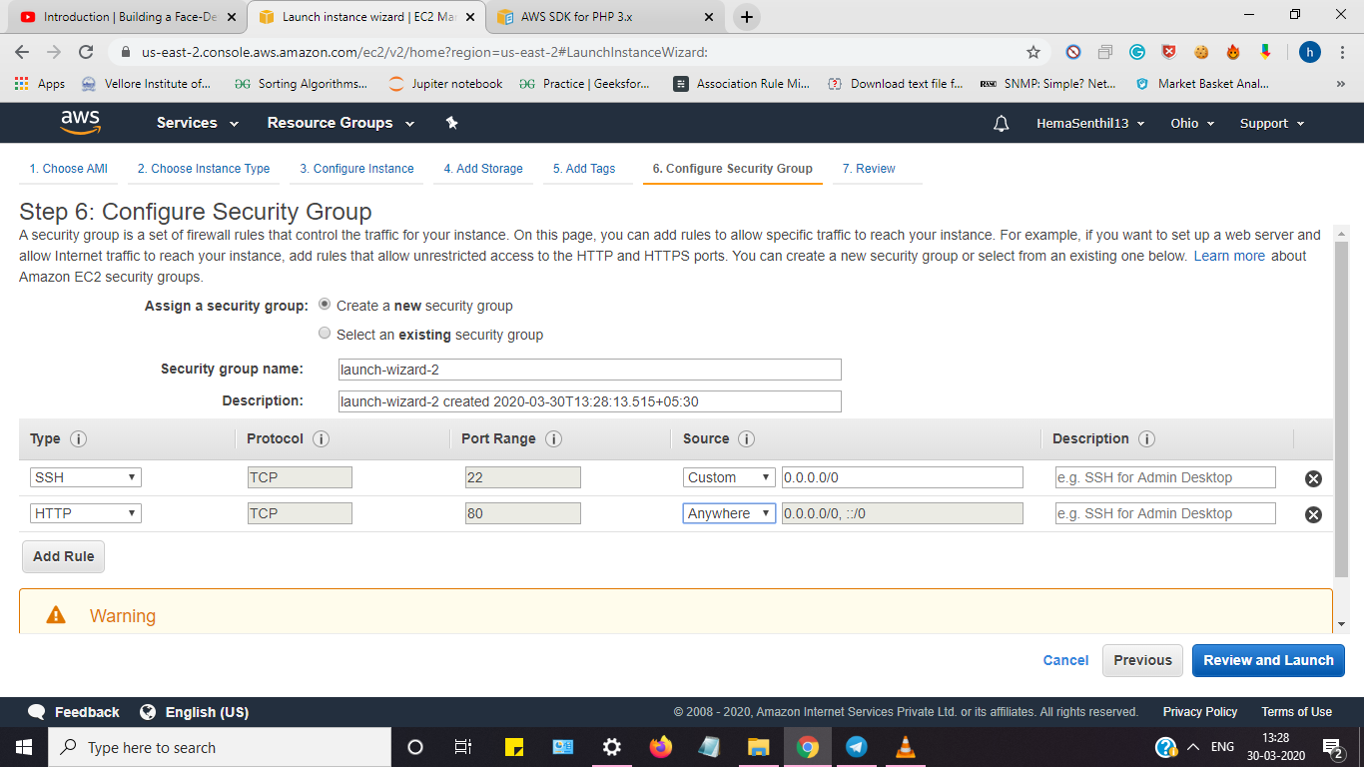

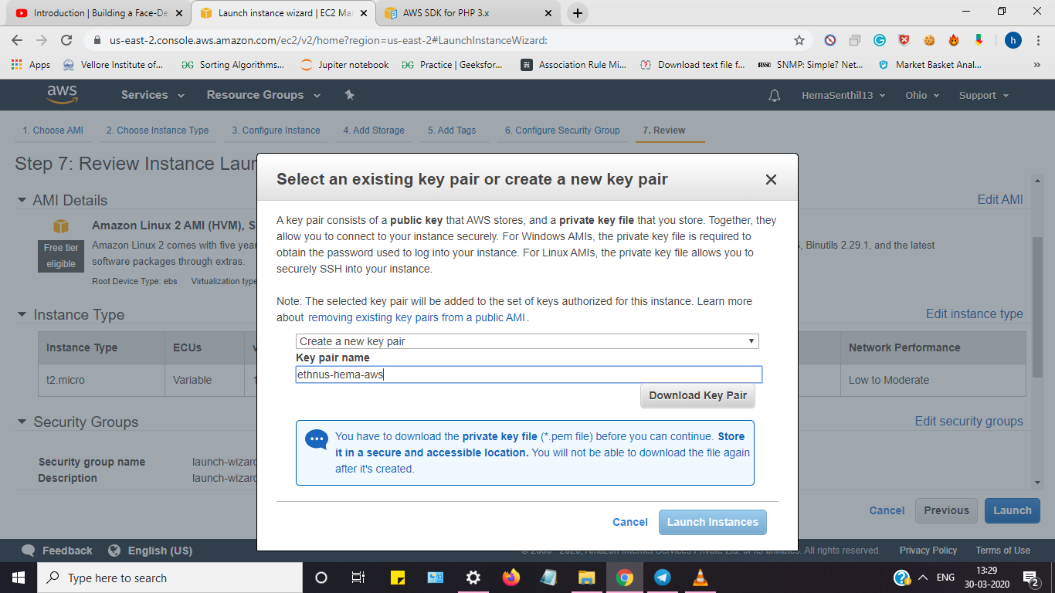**e. Key Pair Download**

**f. PuTTYgen conversion from pem to ppk**

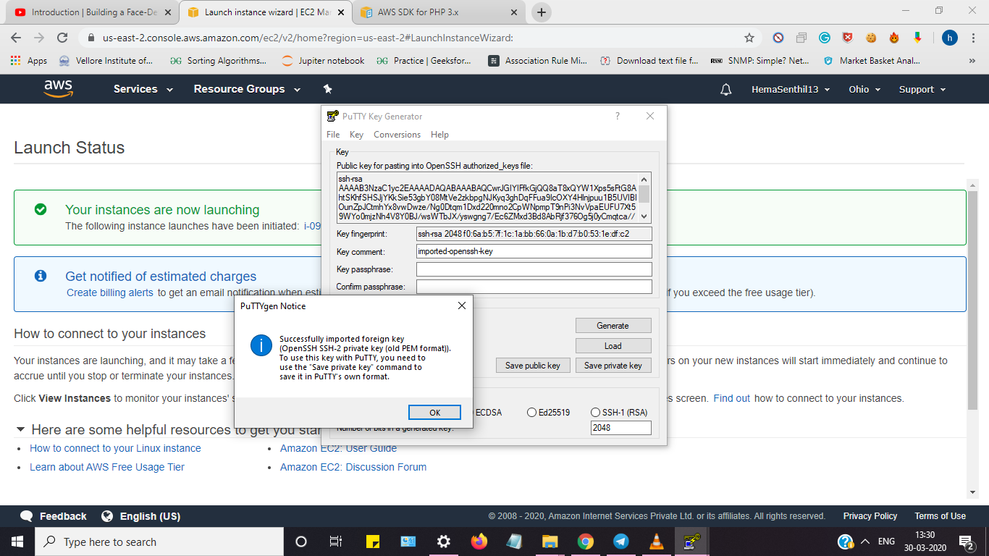

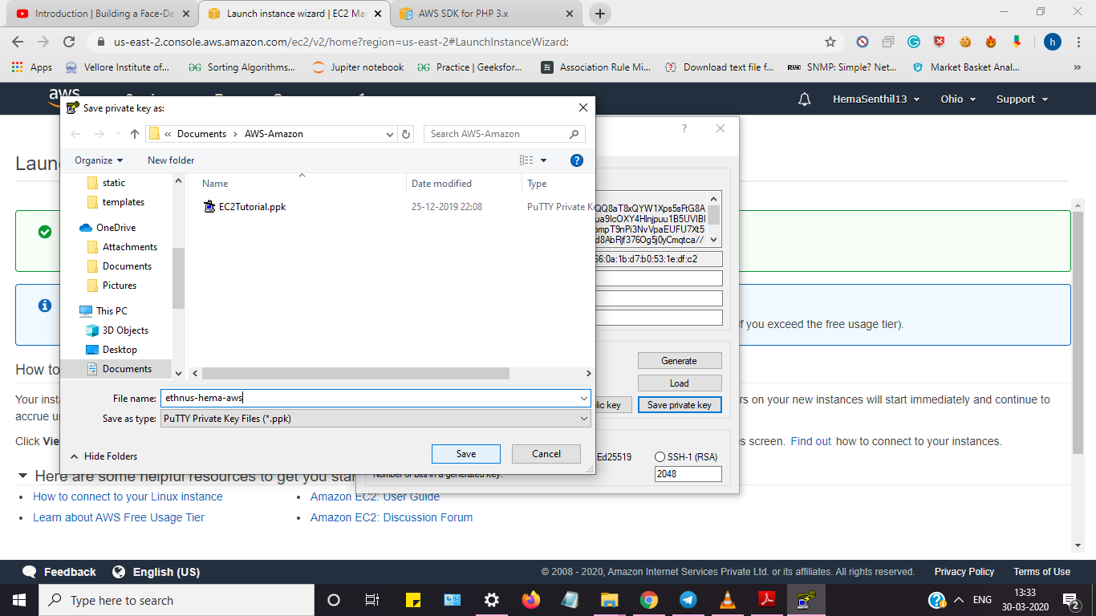

**g. Logged in EC2 black screen**

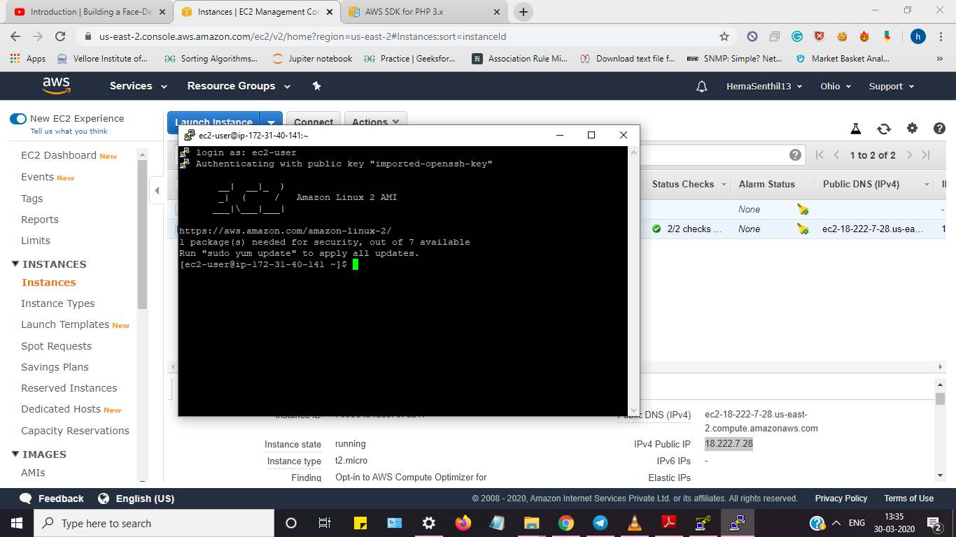

**III. S3 Screenshots**

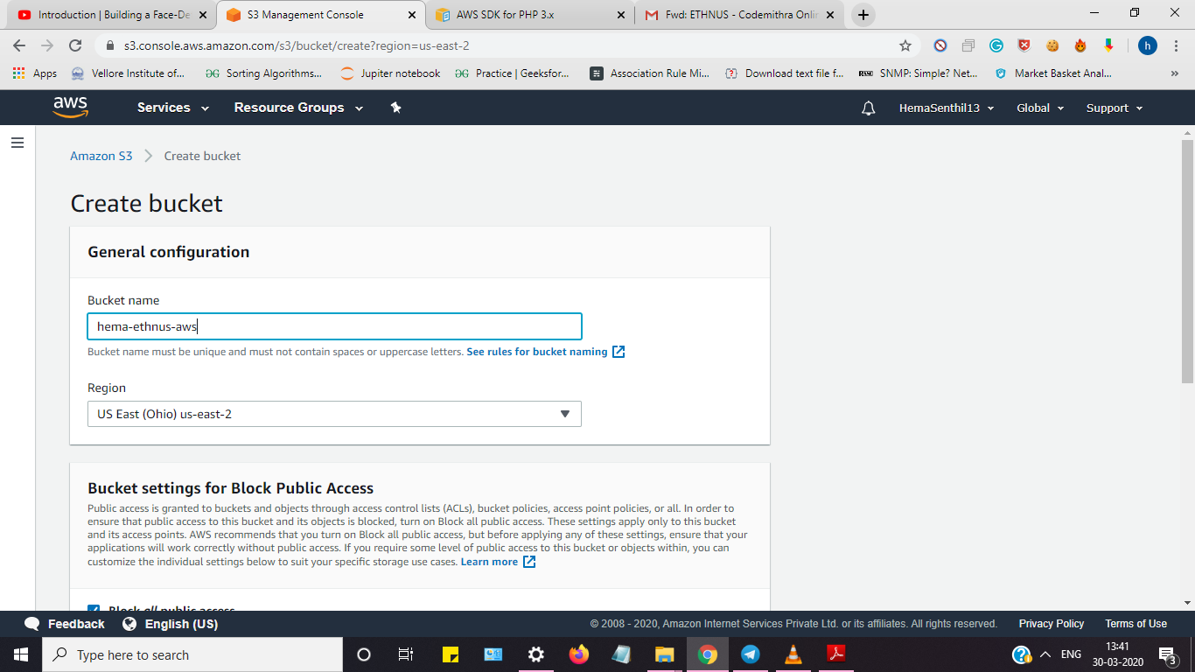**a. Creating a bucket**

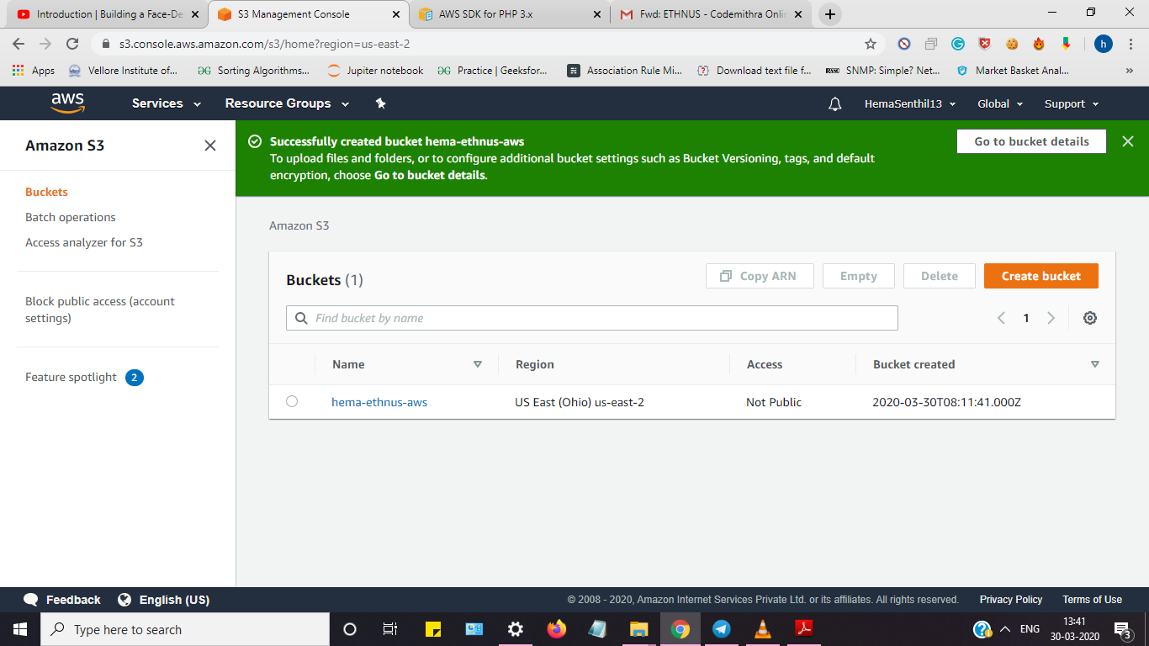

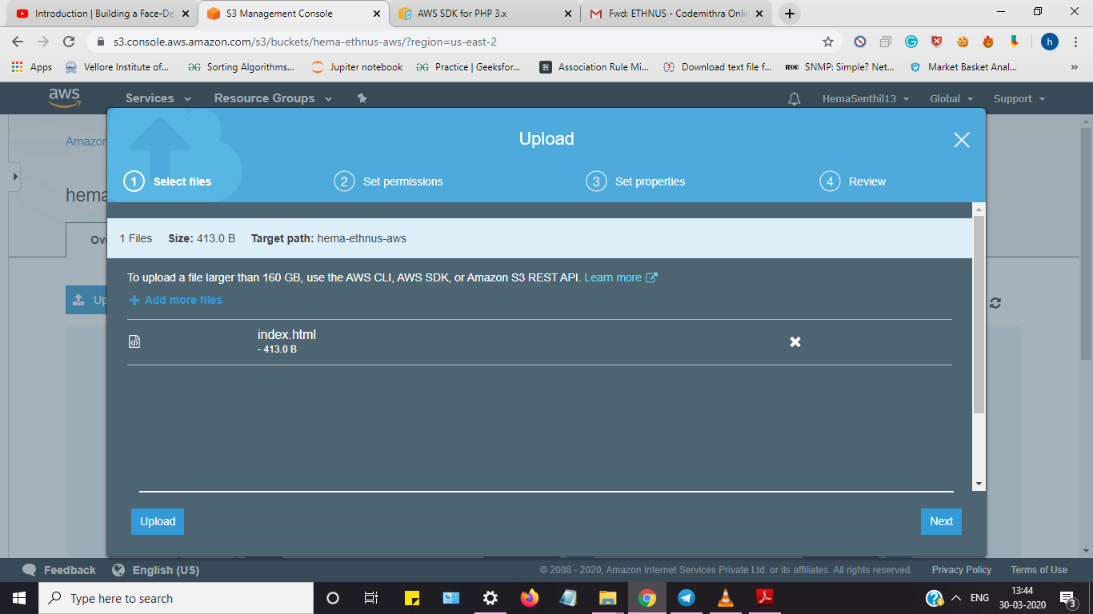**b. Uploading an object**

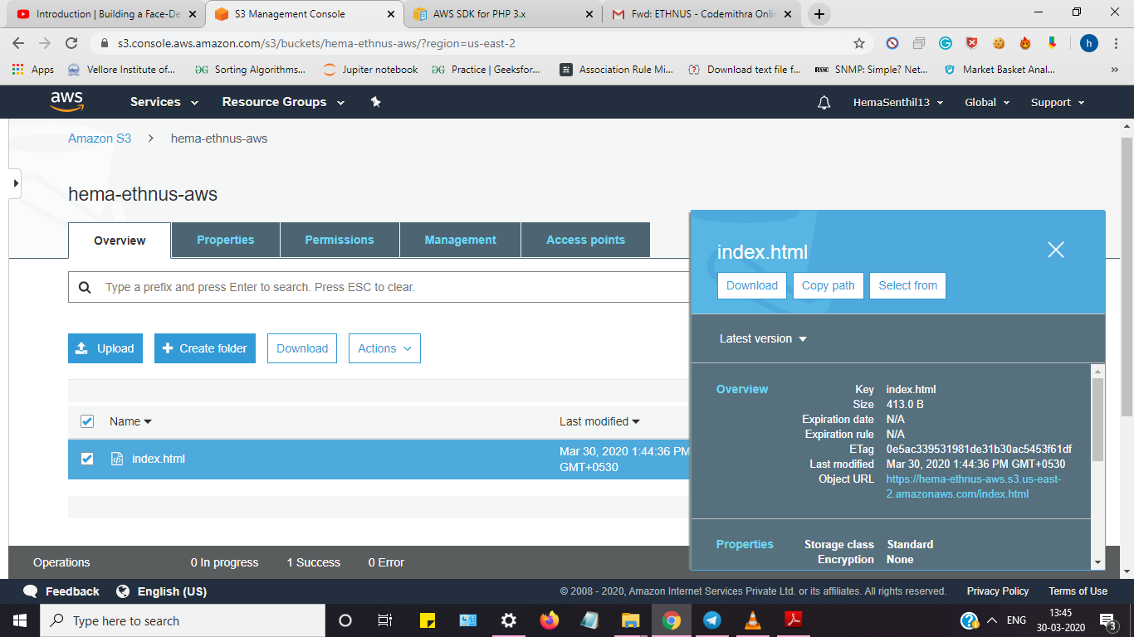

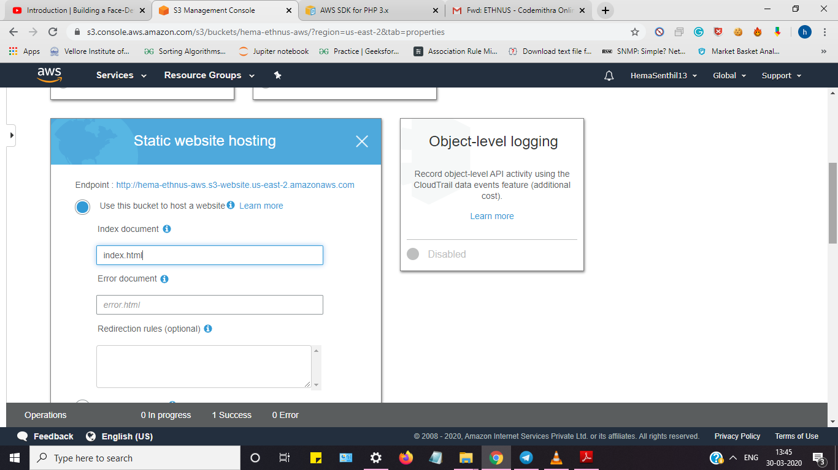**c. Enabling Static Website**

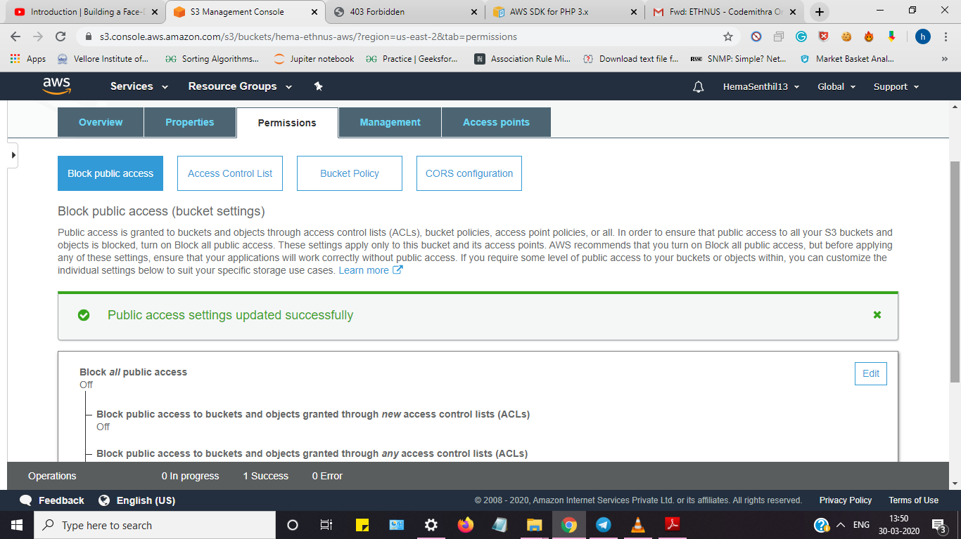**d. Making object public**

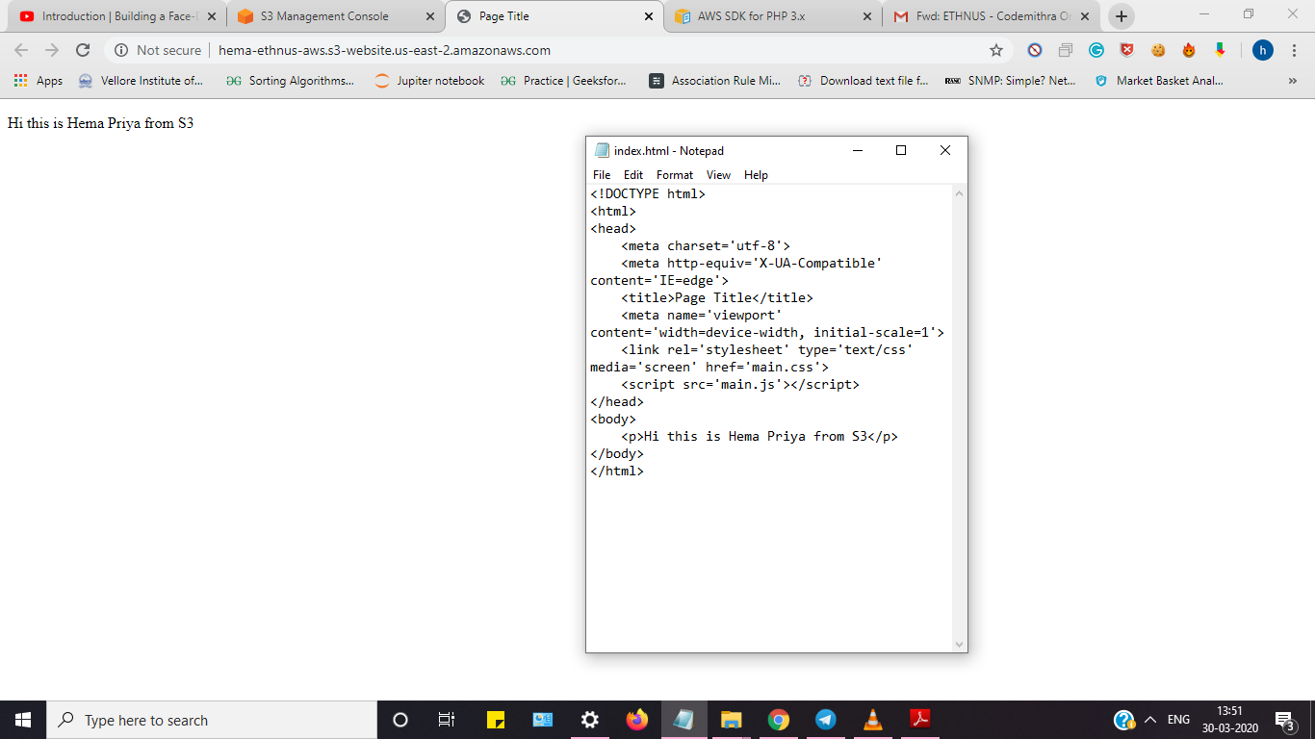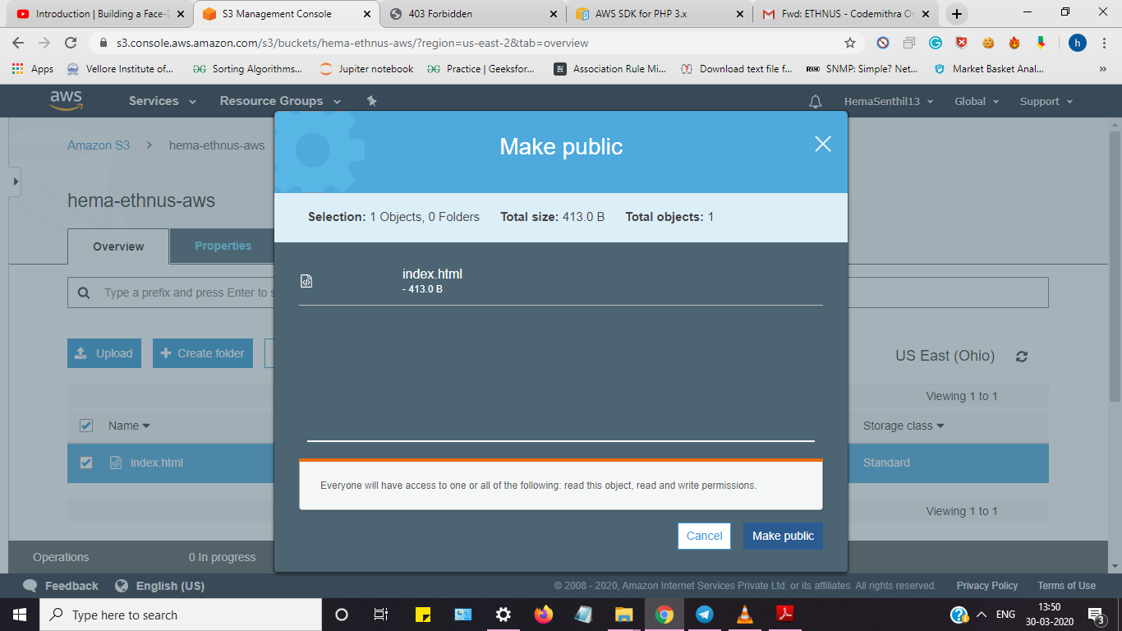**e. Checking S3 link in the browser**

**IV. Rekognition Screenshots**

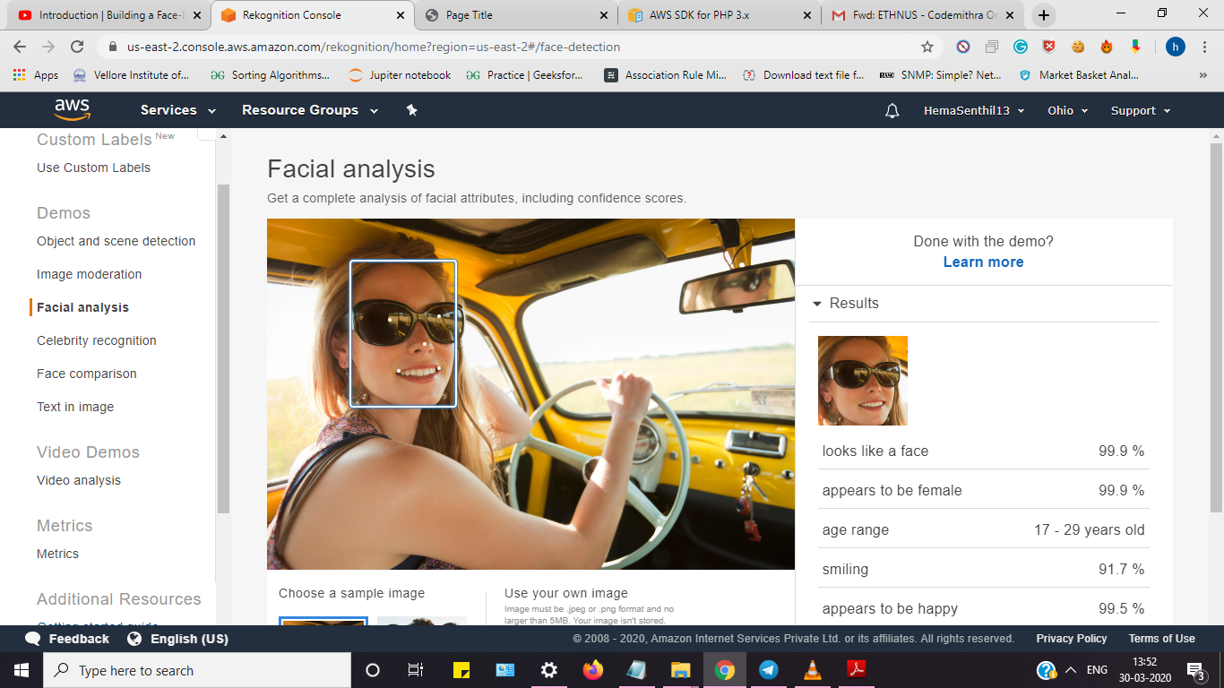**a. Face Detect**

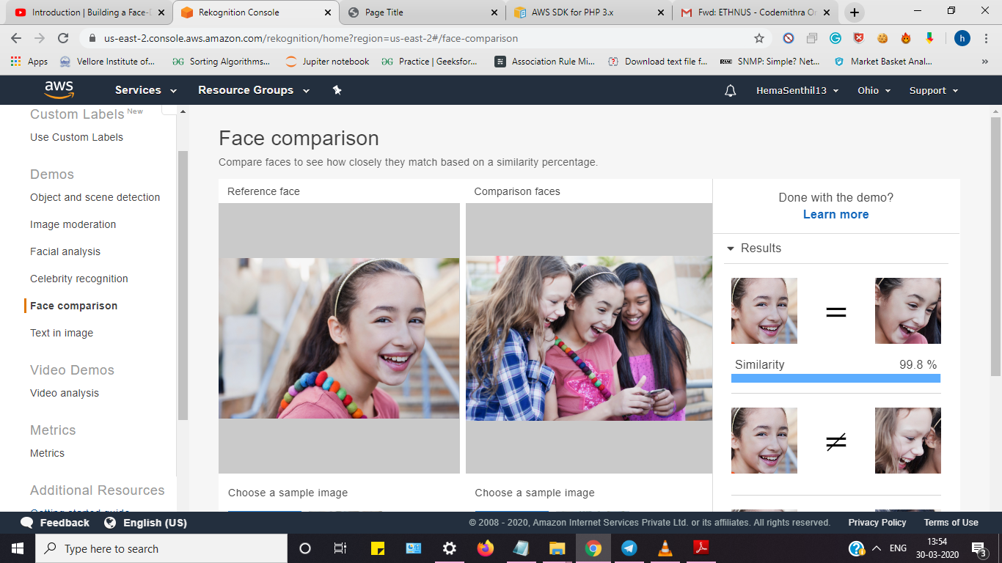**b. Face Compare**

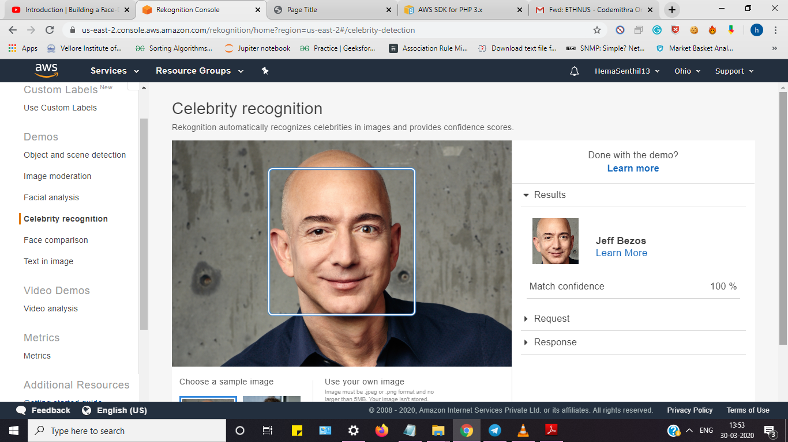**c. Celebrity Recognition**

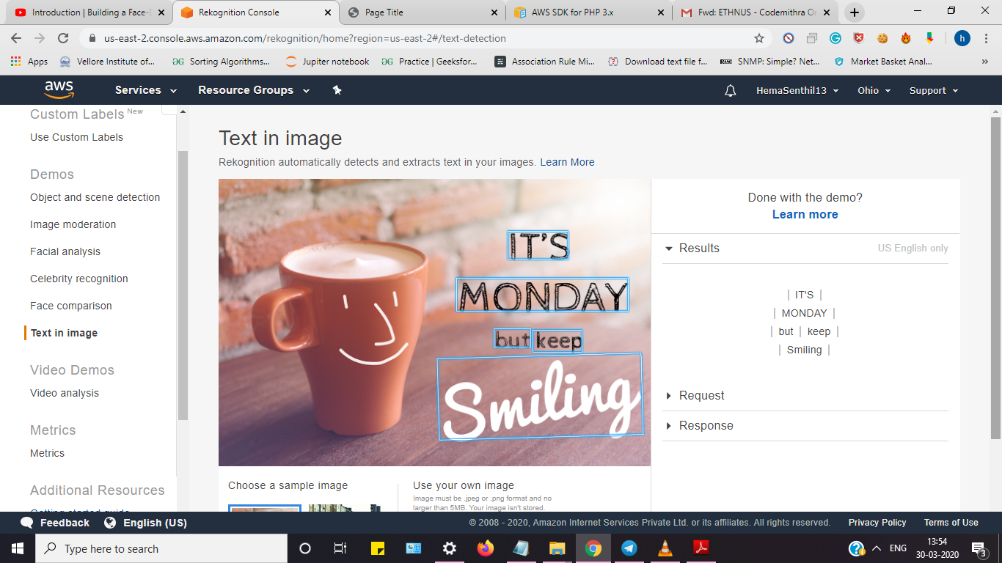**d. Text in Image**

**V. EC2 & S3 Screenshots**

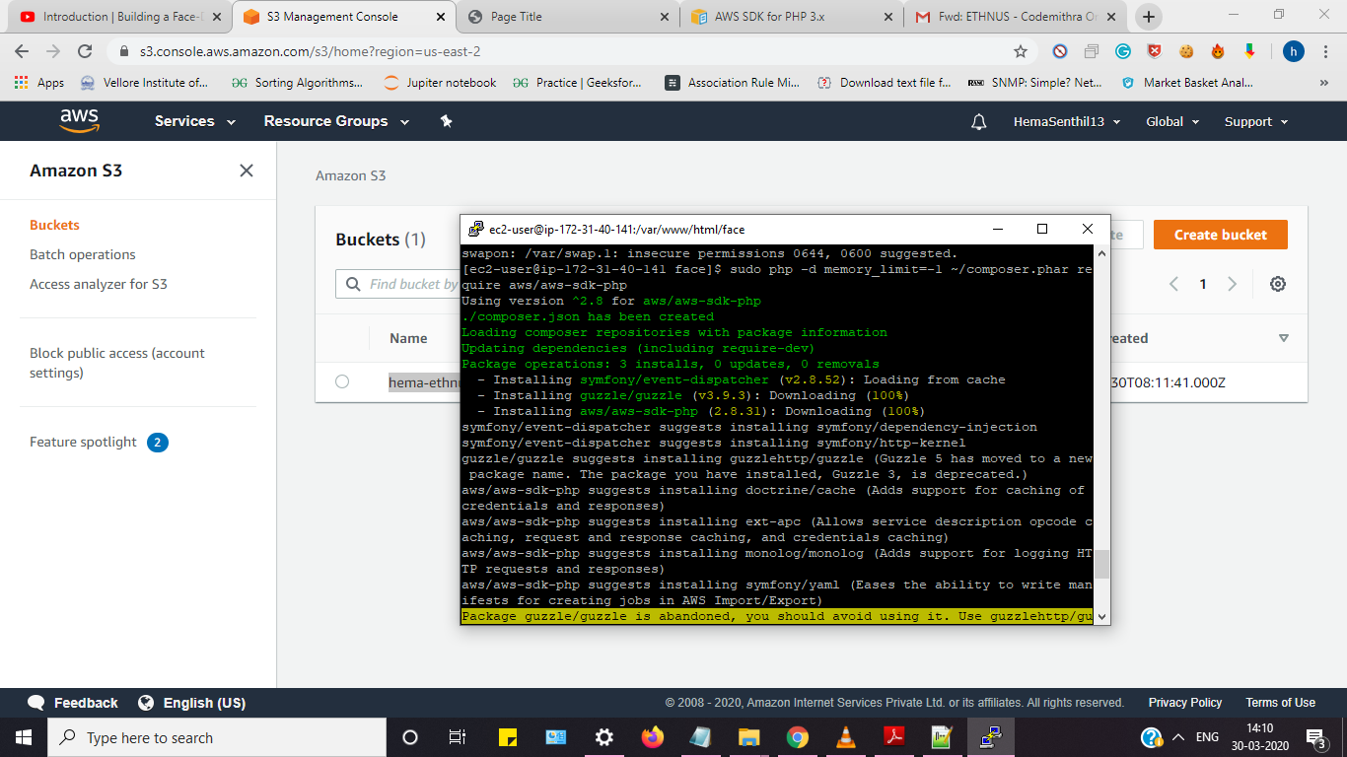**a. Installing aws-sdk**

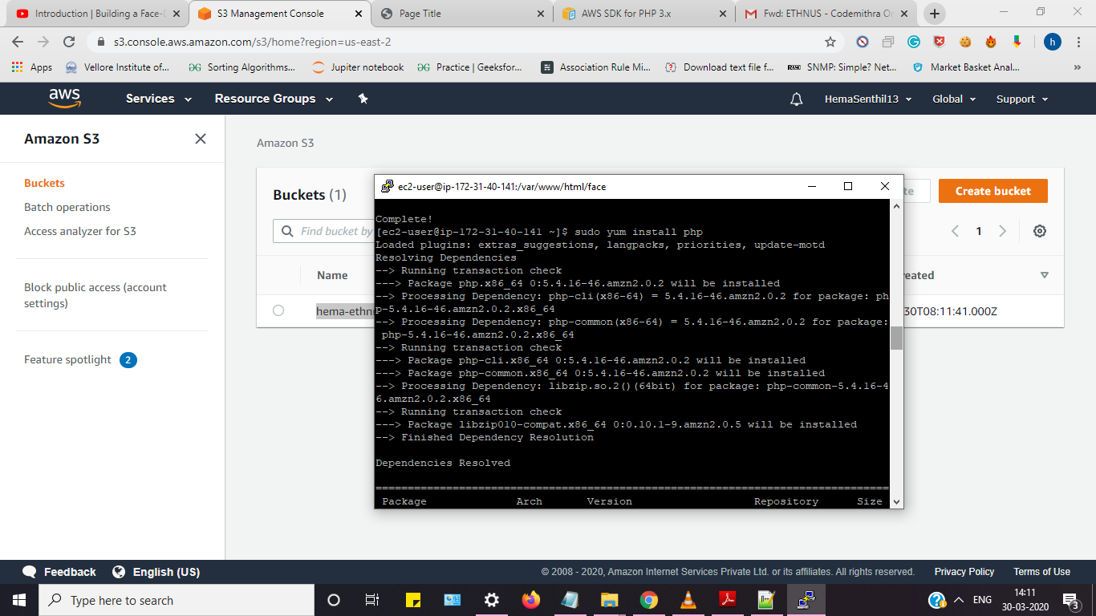**b. Installing php**

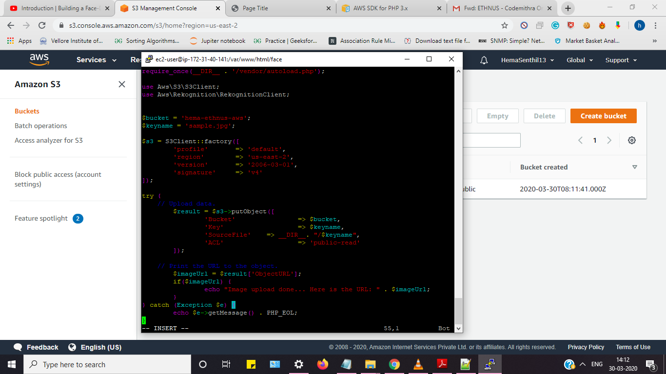**c. Index.php file code**

**d. Upload Success screenshot**

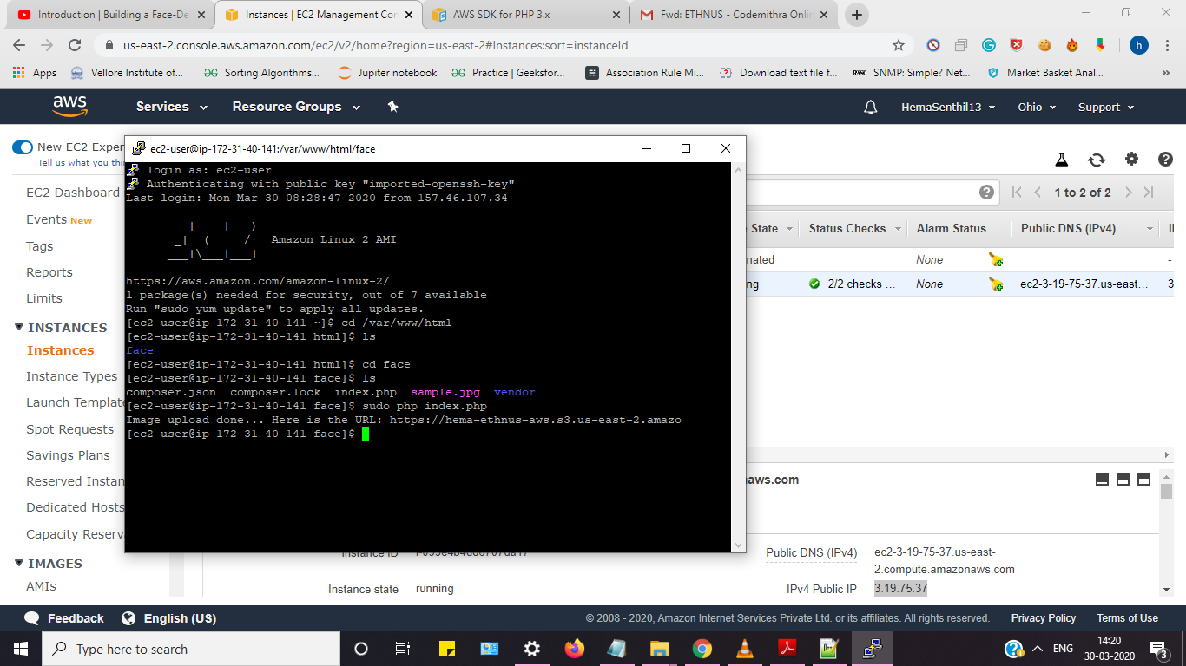

**VI. EC2 and Rekognition**

**a. Face Detect Success Screenshot**

